Net Force: Learning Activity Packet – Level I

An online lab that incorporates data collection, data analysis, graphing and differentiated instruction.

Name : ________________________________________ Date: ___________________________

Discussion: With your lab partner, discuss how you would define force. Record your definition of force in the space below.
____________________________________________________________________________________________________________________________________________________________________________________

Lab Instructions:
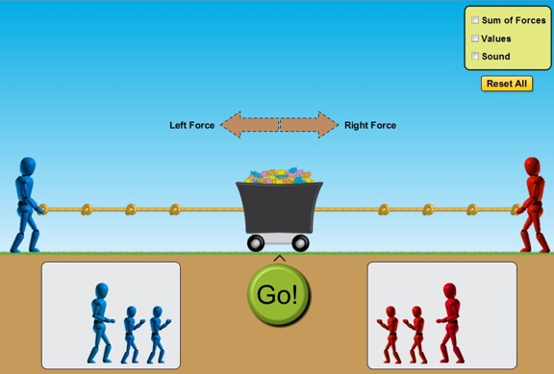
- Go to the Phet App on your iPad or follow the URL below.
http://phet.colorado.edu/en/simulation/forces-and-motion-basics
- Run the program titled Forces and Motion: Basics
- Select the Net Force tab and begin.

Observation and Analysis:

Set up your tug of war competition like the one seen in the picture above.

- What do the brown arrows represent? _____________________________________________.

- Is one arrow larger than the other in this scenario? ____________________________________.

- Are they pointing in the same or different directions? _________________________________.

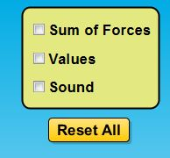
- Go to the menu screen and click the box titled “Values”.

Describe what happened when you clicked the box.
_____________________________________________________________
_____________________________________________________________.

- What is the value of: Left Force ____________ Right Force ____________

- Click the green “Go!” button and write down what you observe in the space below.
____________________________________________________________________________________
____________________________________________________________________________________
____________________________________________________________________________________

- Click the “return” button and move the blue figure so that it is positioned closer to the cart. Leave the red figure at the end of the rope. Did moving the blue figure cause a change in any of the forces acting toward the left?
___________________________________________________________________________________

- Click the box titled “Sum of Forces”. What are the “sum of forces” acting on the cart?

____________________________________________________________________________________

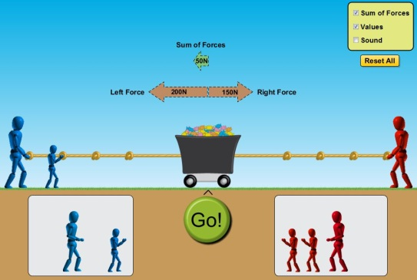
- Now add another blue figure to the left side of the cart.
How did the addition of another blue figure effect the
size of the “Left Force” acting on the cart? What amount
of force is on the “blue side” now? What is the
sum of forces acting on the cart?
___________________________________________

___________________________________________

- Discuss with your lab partner why you think subtraction was used to calculate the sum of the forces in the examples we’ve seen thus far? Record your explanation below.

________________________________________________________________________________________________________________________________________________________________________

- Make a prediction about what will happen when you click the green “Go!” button. Set up a simulation like that seen in the picture above. Click the “Go!” button and describe what you observe. Did your observation match your initial prediction? Did the cart move in the direction of the greater force?

________________________________________________________________________________________________________________________________________________________________________

Use the simulation to complete the table below:

 | Left Force  (N) | Right Force  (N) | Sum of Forces  (N) | Direction of cart movement once “GO!” is pressed.
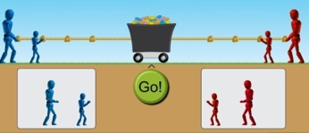
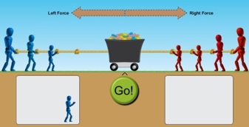

Summary:
- During the simulation, when the sum of forces acting on the cart equaled zero, did the cart move?
______________________________________________________________________________
- When the cart moved, were the forces acting upon it balanced or unbalanced? Explain.
____________________________________________________________________________________________________________________________________________________________________________________________________________________________________________________________
- When the cart moved, did it always move in the direction of the “sum of forces”?
___________________________________________________________________________________
- With your lab partner, write a summary of what you have learned while performing the lab simulation on Net Force.
____________________________________________________________________________________________________________________________________________________________________________________________________________________________________________________________________________________________________________________________________________________________________________________________________________________________________________________________________________________________________________________________________________________________________________________________________________

Motion: Learning Activity Packet – Level II

Lab Instructions
- Click on the “Motion” Phet Simulation.
- Check all of the boxes “Force, Values, Masses, and Speed”.
- Click the pause button.
- Place a crate on the skateboard, change the “Applied Force” to 200N. Your screen should look like the picture to the right.
- Press the play button and count to ten. What happens? (Look at the speed.)
____________________________________________________________________________________

- Repeat steps 3-5 with the refrigerator. What happens?
____________________________________________________________________________________

- Click the “Reset All” button (orange button to the right).
- Repeat steps 2-5 using different objects and different applied forces.
- What happens to the speed? Does it slow down as different objects are added and the applied force is different? Why do you think this happens?
____________________________________________________________________________________

____________________________________________________________________________________

____________________________________________________________________________________
- How long will it take for various objects to reach maximum speed (when the hand on the speedometer cannot go any further)? Fill in the table below. You will need to use a timer on your phone to help you.
Object | Mass | Applied Force (N) | Time
1 crate |  | 300N
2 crates |  | 300N
Refrigerator |  | 300N
Man |  | 300N
Girl |  | 300N
Mystery Object |  | 300N

- Do you think the object’s mass determines how long it will take for that object to reach maximum speed with an applied force of 300N? Explain your answer.
____________________________________________________________________________________

____________________________________________________________________________________

____________________________________________________________________________________
- What approximate mass do you think the mystery object has? Hint: Look at the time it took to reach maximum speed and compare your times with other objects and their mass.
____________________________________________________________________________________

Friction: Learning Activity Packet – Level III
Lab Instructions
- Click on the “Friction” Phet Simulation.
- Check all of the boxes “Force and Speed”.
- Click the pause button.
- Place the refrigerator on the screen and apply 500N. Your screen should look like the picture to the right.
- What happened?
____________________________________
____________________________________
- Click the “Reset” button.
- Check all of the boxes “Values and Speed”.
- Place the refrigerator on the screen and apply 500N. Slide the friction bar to none.
- What happened as you slide the friction bar closer to “none”?
____________________________________________________________________________________
- Click the “Reset” button.
- Check all of the boxes “Values, Sum of Forces, Masses, and Speed”.
- Click the pause button.
- Complete the table below using the given values for applied, friction, and sum of forces to determine the missing value.
Object | Applied Force (N) | Friction Force (N) | Sum of Forces (N)
Crate | 200 | 125
Man | 472 |  | 272
Refrigerator |  | 51 | 99
Girl | 363 | 100
Garbage Can | 500 |  | 375
- What do you notice about the values within the table? What equation could you write to represent your findings?
____________________________________________________________________________________________________________________________________________________________________________________________________________________________________________________________

Acceleration: Learning Activity Packet – Level IV
Lab Instructions
- Click on the “Acceleration” Phet Simulation.
- Use the simulation to answer each of the following questions:
  - How do you make the box speed up?
______________________________________________________________________________
  - How do you make the box move at a constant speed?
______________________________________________________________________________
  - Once the box is moving, how do you make it stop?
______________________________________________________________________________
  - Describe the motion the box undergoes when you make it change direction.
______________________________________________________________________________
- Any change in motion is called acceleration. When does the box accelerate?
____________________________________________________________________________________
- What is the acceleration of each item in the table below? I did the first one. Check my answer, then find the acceleration of the others. Hint: You may have to play around with the friction slide.
Object | Mass | Acceleration | Force
Girl | 40kg | 10m/s² | 400N
Man | 80kg |  | 400N
Bucket | 100kg |  | 500N
- Use the table above to answer the following questions:
  - How do you find force? (State the equation using words)
Force = _________________________________________________
  - How do you find acceleration? (State the equation using words)
Acceleration = ____________________________________________
  - How do you find mass? (State the equation using words)
Mass = __________________________________________________
- How much force would the orange man need to use for the 200kg refrigerator to accelerate at 5m/s²? Show your work.
__________________________________________________________________________________

